Report 2
Karim rahimian
Figure 1 shows my designed oncolplot. The order of the gene mutation frequency is reversed from bottom to up deliberately. Figure 2 shows the real outcome of the oncoplot library. We filtered the Gene names which has frequency fewer that 5 for all samples.

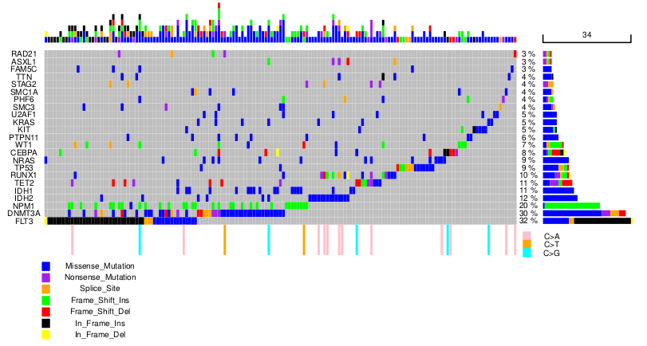Figure 1: My designed oncoplot

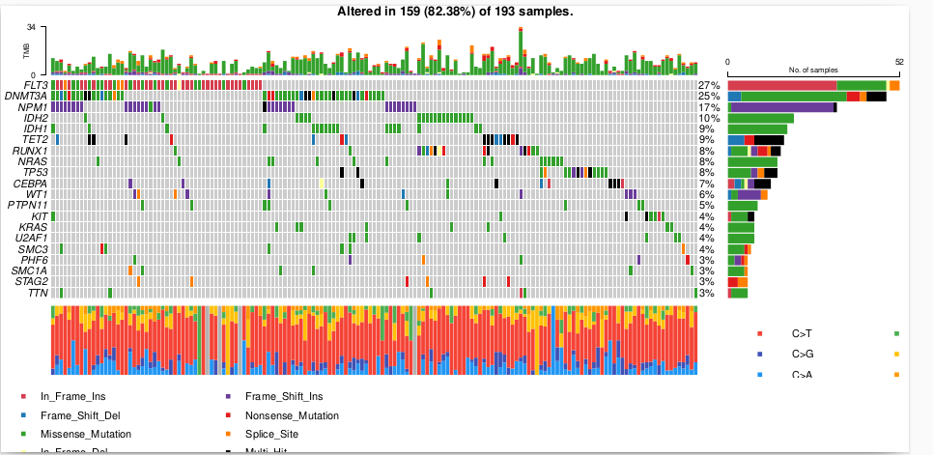Figure 2: Oncoplot from the oncoplot library

